Anthropometric Indices to Reveal Nutritional Status (Cover Page [Insert – Cover Page])

[Insert – Page Break] Contents (Arial Black, 20)
[Insert – Page Break] Introduction [Home – Styles – Heading 1]
The main anthropometric indices able to reveal nutritional status of neonates are:
- Ponderal index
- Body mass index
- Head circumference/Abdominal circumference
- Mid-arm circumference/Head circumference
- Weight/Length (W/L)
[Insert – Page Break] Ponderal index [Home – Styles – Heading 1]
It was first proposed 1921 as "Corpulence Index" by Rohrer [Rohrer F. Der Index der Körperfülle als Maß des Ernährungszustandes. Münchner Med Wschr 1921;68:580-582.].
  - Abbreviation: PI
  - Provide the relationship between mass and height.
  - Is similar to the body mass index.
  - Formulas: (Insert formulas with Insert Equation and delete the provided formulas!)
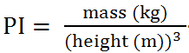 | normal values for 12 month old infant: [10.3 – 13.9]
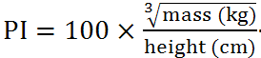 | normal values: [2.175 - 2.4]
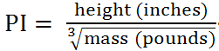 | normal values: [12.49 - 13.92]

[Insert – Page Break] Body mass index [Home – Styles – Heading 1]
It is also knows as Quetelet index. It was invented between 1830 and 1850 by the Belgian polymath Adolphe Quetelet [Eknoyan Garabed. Adolphe Quetelet (1796–1874)-the average man and indices of obesity. Nephrol. Dial. Transplant. 2008;23(1):47-51.].
  - Abbreviation: BMI
  - Is a heuristic proxy for human body fat based on an individual's weight and height.
  - Formulas: (Create a new table based on the model below and use Insert Equation to include the corresponding equations! Delete the provided table (image table)!)
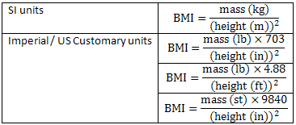

  - The International Classification of adult underweight, overweight and obesity according to BMI: (Create a new table based on the model below and use Insert Equation to include the corresponding equations! Delete the old table (image table)!)
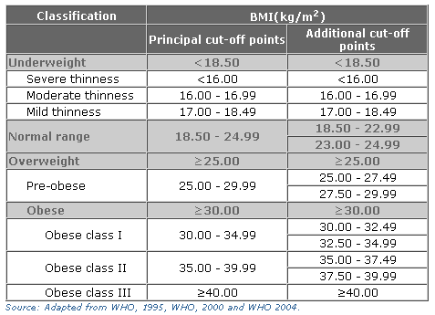

[Insert – Page Break] Head circumference/Abdominal circumference [Home – Styles – Heading 1]
  - Abbreviation: HC/AC ratio
  - The HC/AC ratio is a means of distinguishing different patterns of growth retardation with a high ratio implying malnutrition of the fetus [Colley NV, Tremble JM, Henson GL, Cole TJ. Head circumference/abdominal circumference ratio, ponderal index and fetal malnutrition. Should head circumference/abdominal circumference ratio be abandoned? Br J Obstet Gynaecol 1991;98(6):524-7.].
[Insert – Page Break] Mid-arm circumference/Head circumference [Home – Styles – Heading 1]
  - Abbreviation: MAC/OFC
  - Mid-arm circumference is a very good indicator of low and insufficient birth weigh [Figueira BB, Segre CA. Mid-arm circumference and mid-arm/head circumference ratio in term newborns. Sao Paulo Med J 2004;122(2):53-9.].
[Insert – Page Break] Weight/Length [Home – Styles – Heading 1]
- Abbreviation: W/L
- Reflects the intrauterine nutritional state [Fok TF, Hon KL, Ng PC, Wong E, So HK, Lau J, Chow CB, Lee WH; Hong Kong Neonatal Measurements Working Group. Use of anthropometric indices to reveal nutritional status: normative data from 10,226 Chinese neonates. Neonatology. 2009;95(1):23-32.].
- Braga and Lima concluded that weight/length ratio is the best alternative to assess the nutritional status of infants at birth [Braga TD, Lima Mde C. [Weight/length ratio: is it a good index to assess the nutritional status of full-term newborns?]. J Pediatr (Rio J) 2002;78(3):219-24.].
[Insert – Page Break] References [Home – Styles – Heading 1]

